EK-B

PIC16F628A
Information contained in this publication regarding device applications and the like is intended through suggestion only and may be superseded by updates. It is your responsibility to ensure that your application meets with your specifications. No representation or warranty is given and no liability is assumed by Microchip Technology Incorporated with respect to the accuracy or use of such information, or infringement of patents or other intellectual property rights arising from such use or otherwise. Use of Microchip’s products as critical components in life support systems is not authorized except with express written approval by Microchip. No licenses are conveyed, implicitly or otherwise, under any intellectual property rights.
Pin Diagrams

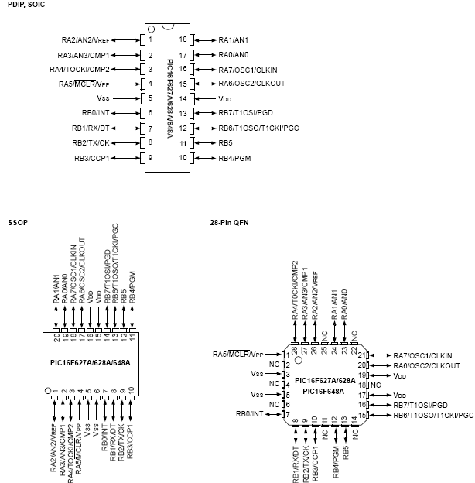
Block Diagrams

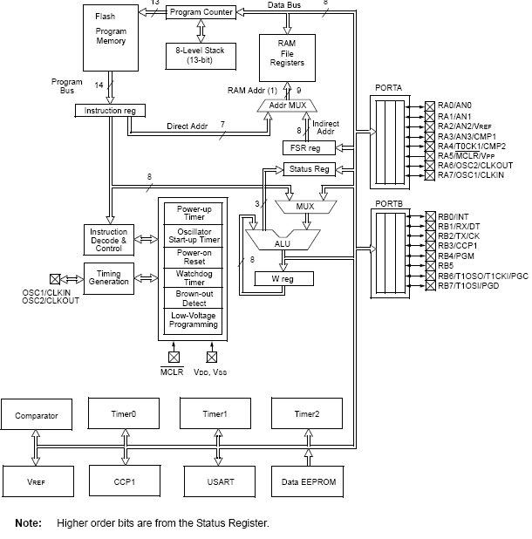

3.1 Clocking Scheme/Instruction Cycle

The clock input (OSC1/CLKIN/RA7 pin) is internally divided by four to generate four non-overlapping quadrature clocks namely Q1, Q2, Q3 and Q4. Internally, the program counter (PC) is incremented every Q1, the instruction is fetched from the program memory and latched into the instruction register in Q4. The instruction is decoded and executed during the following Q1 through Q4. The clocks and instruction execution flow is shown in Figure 3-2.

3.2 Instruction Flow/Pipelining

An instruction cycle consists of four Q cycles (Q1, Q2, Q3 and Q4). The instruction fetch and execute are pipelined such that fetch takes one instruction cycle while decode and execute takes another instruction cycle. However, due to the pipelining, each instruction effectively executes in one cycle. If an instruction causes the program counter to change (e.g., GOTO) then two cycles are required to complete the instruction (Example 3-1). A fetch cycle begins with the program counter (PC) incrementing in Q1. In the execution cycle, the fetched instruction is latched into the Instruction Register (IR) in cycle Q1. This instruction is then decoded and executed during the Q2, Q3, and Q4 cycles. Data memory is read during Q2 (operand read) and written during Q4 (destination write).

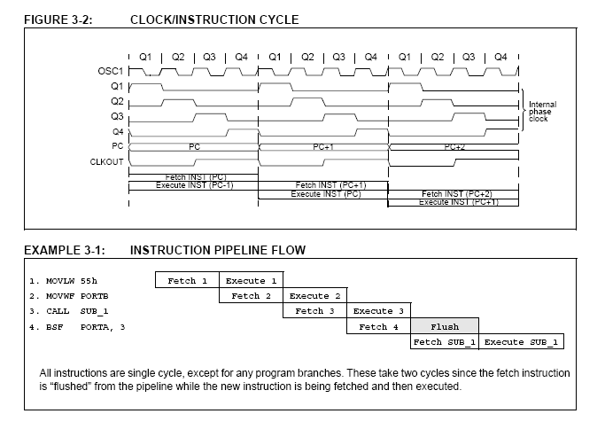
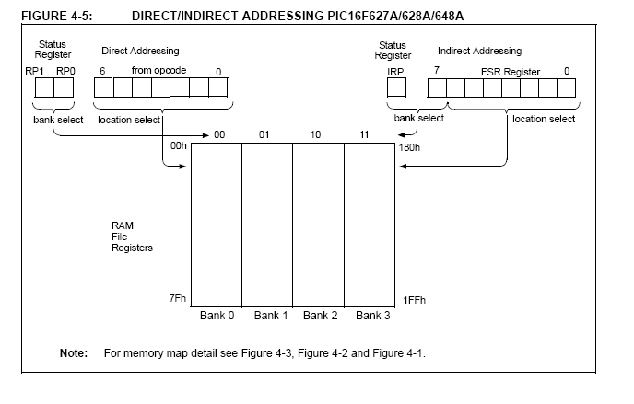

Packaging information
